PYTHON SCRIPT

B C SACHIN

680020bcsachin-bucket

gcloud version

gcloud auth login

gcloud init

python3 -m pip install --user --upgrade pip

sudo pip install virtualenv

python3 -m venv .venv

source .venv/bin/activate

pip3 install virtualenv

python3 -m venv .venv

source .venv/bin/activate

pip freeze

vim requirements.txt

gcloud auth application-default login

echo "">680020bcsachin-first-upload.py

1a.

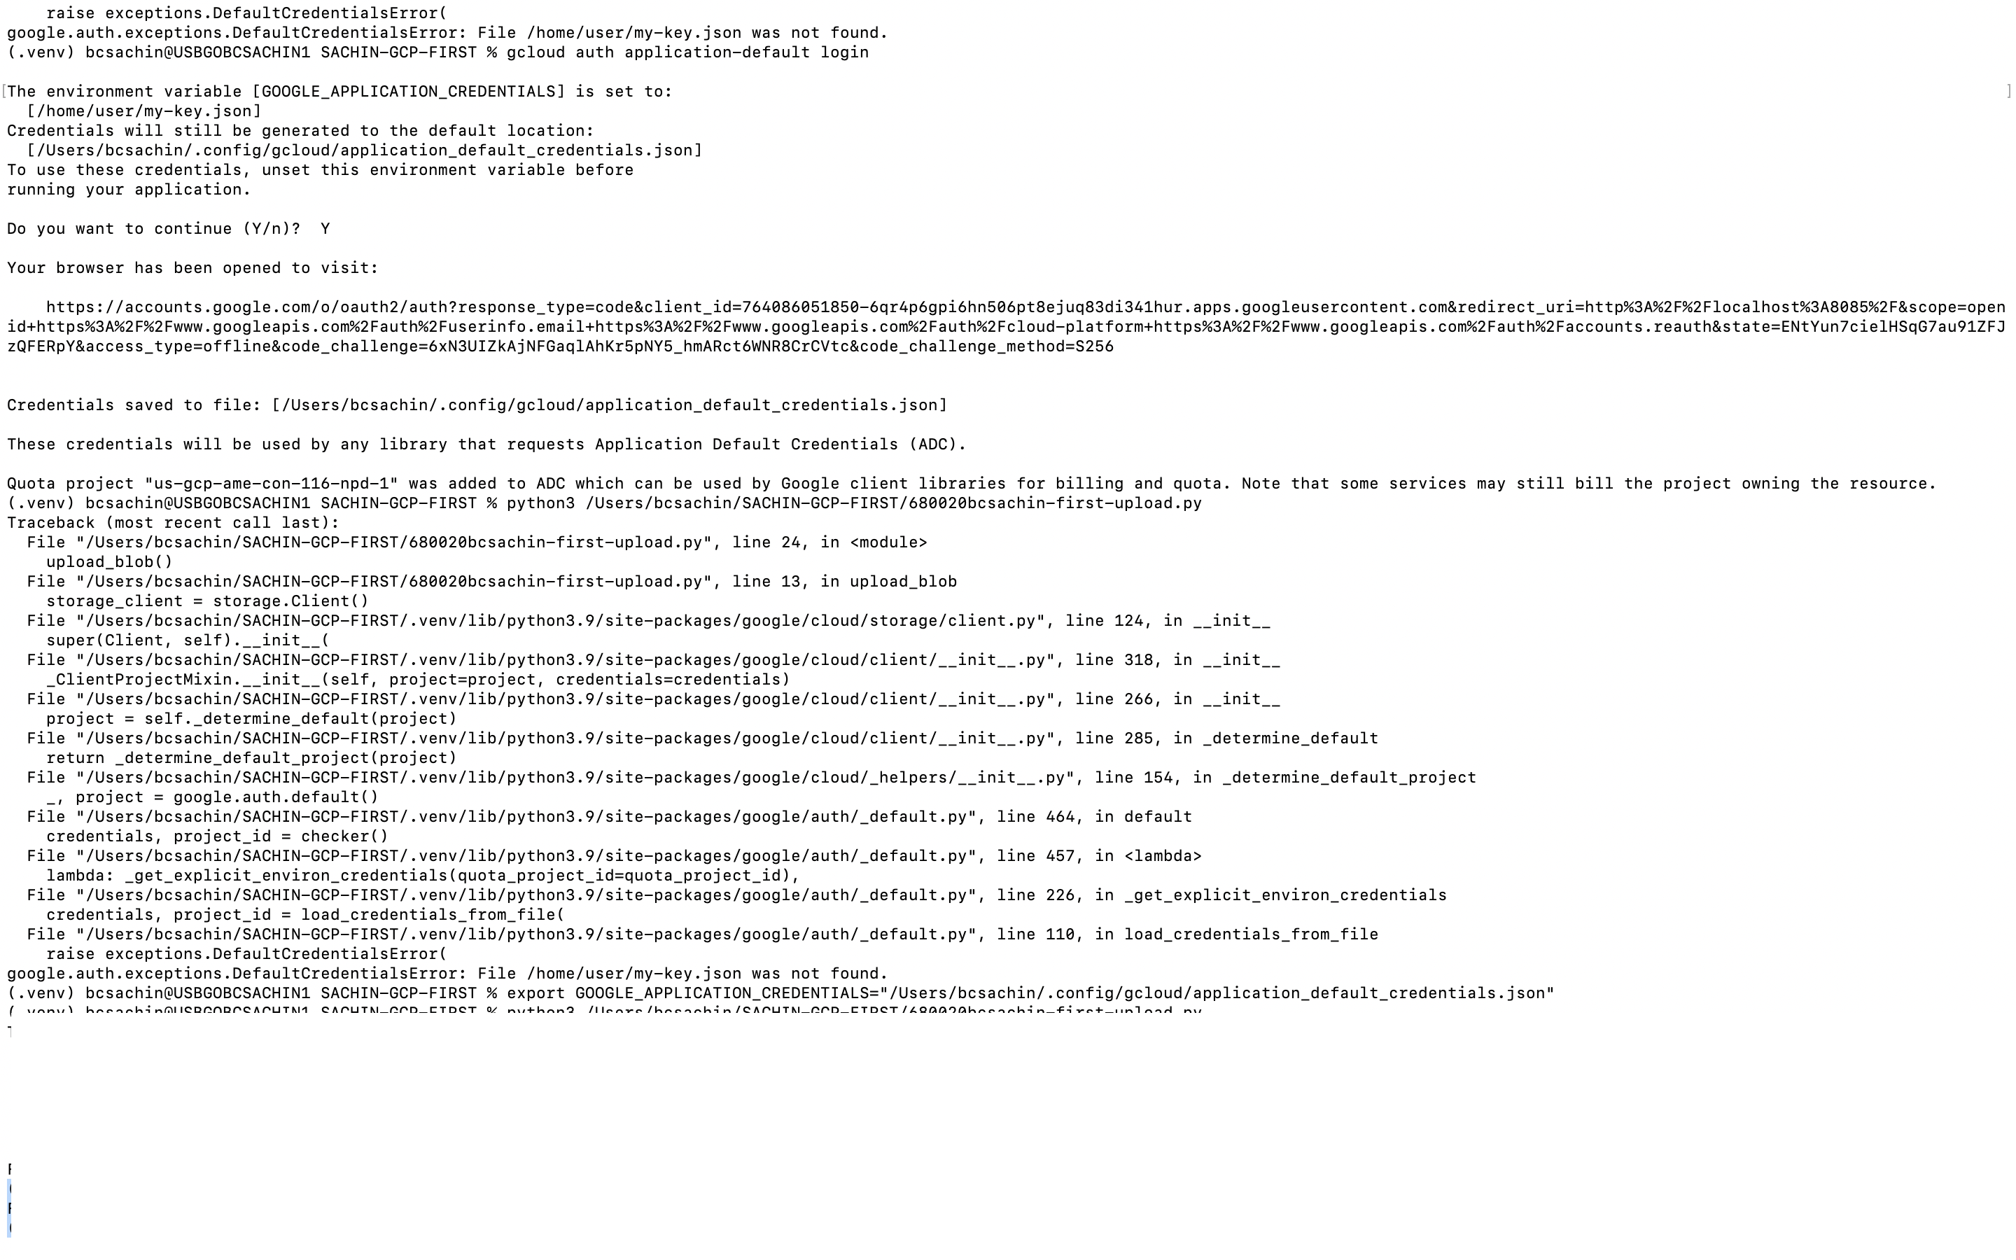

CREATE 680020bcsachin-bucket

UPLOAD FILE USING BELOW SCRIPT

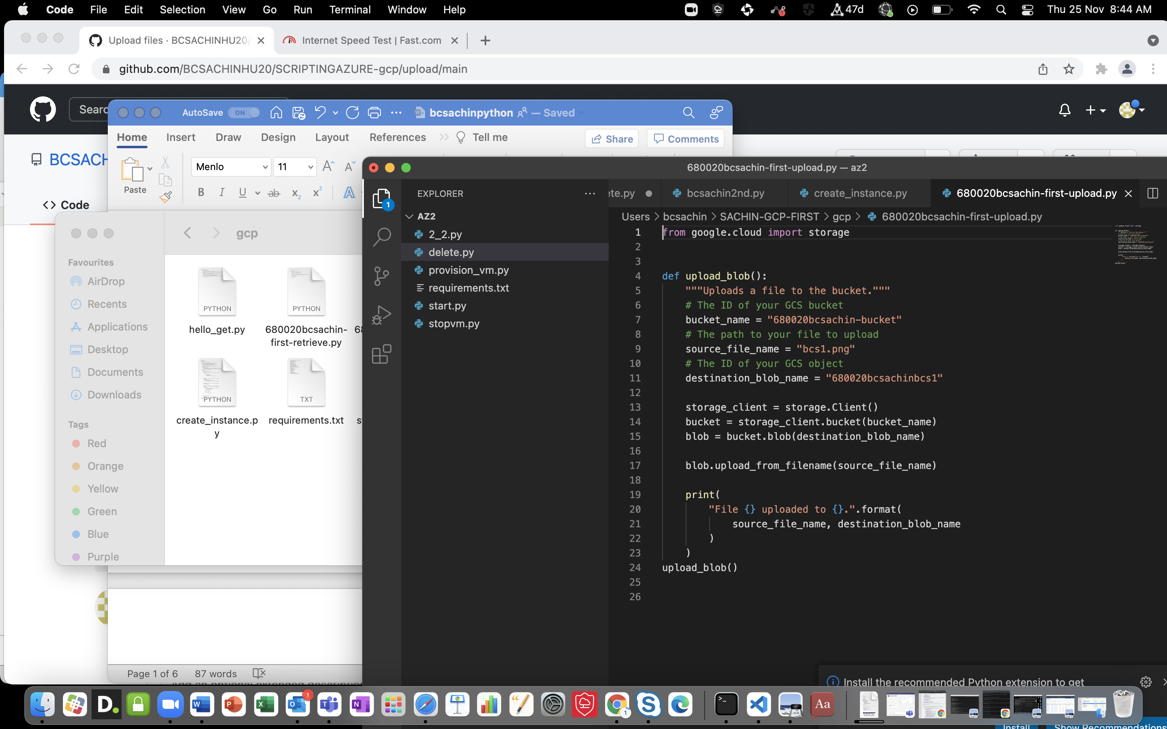

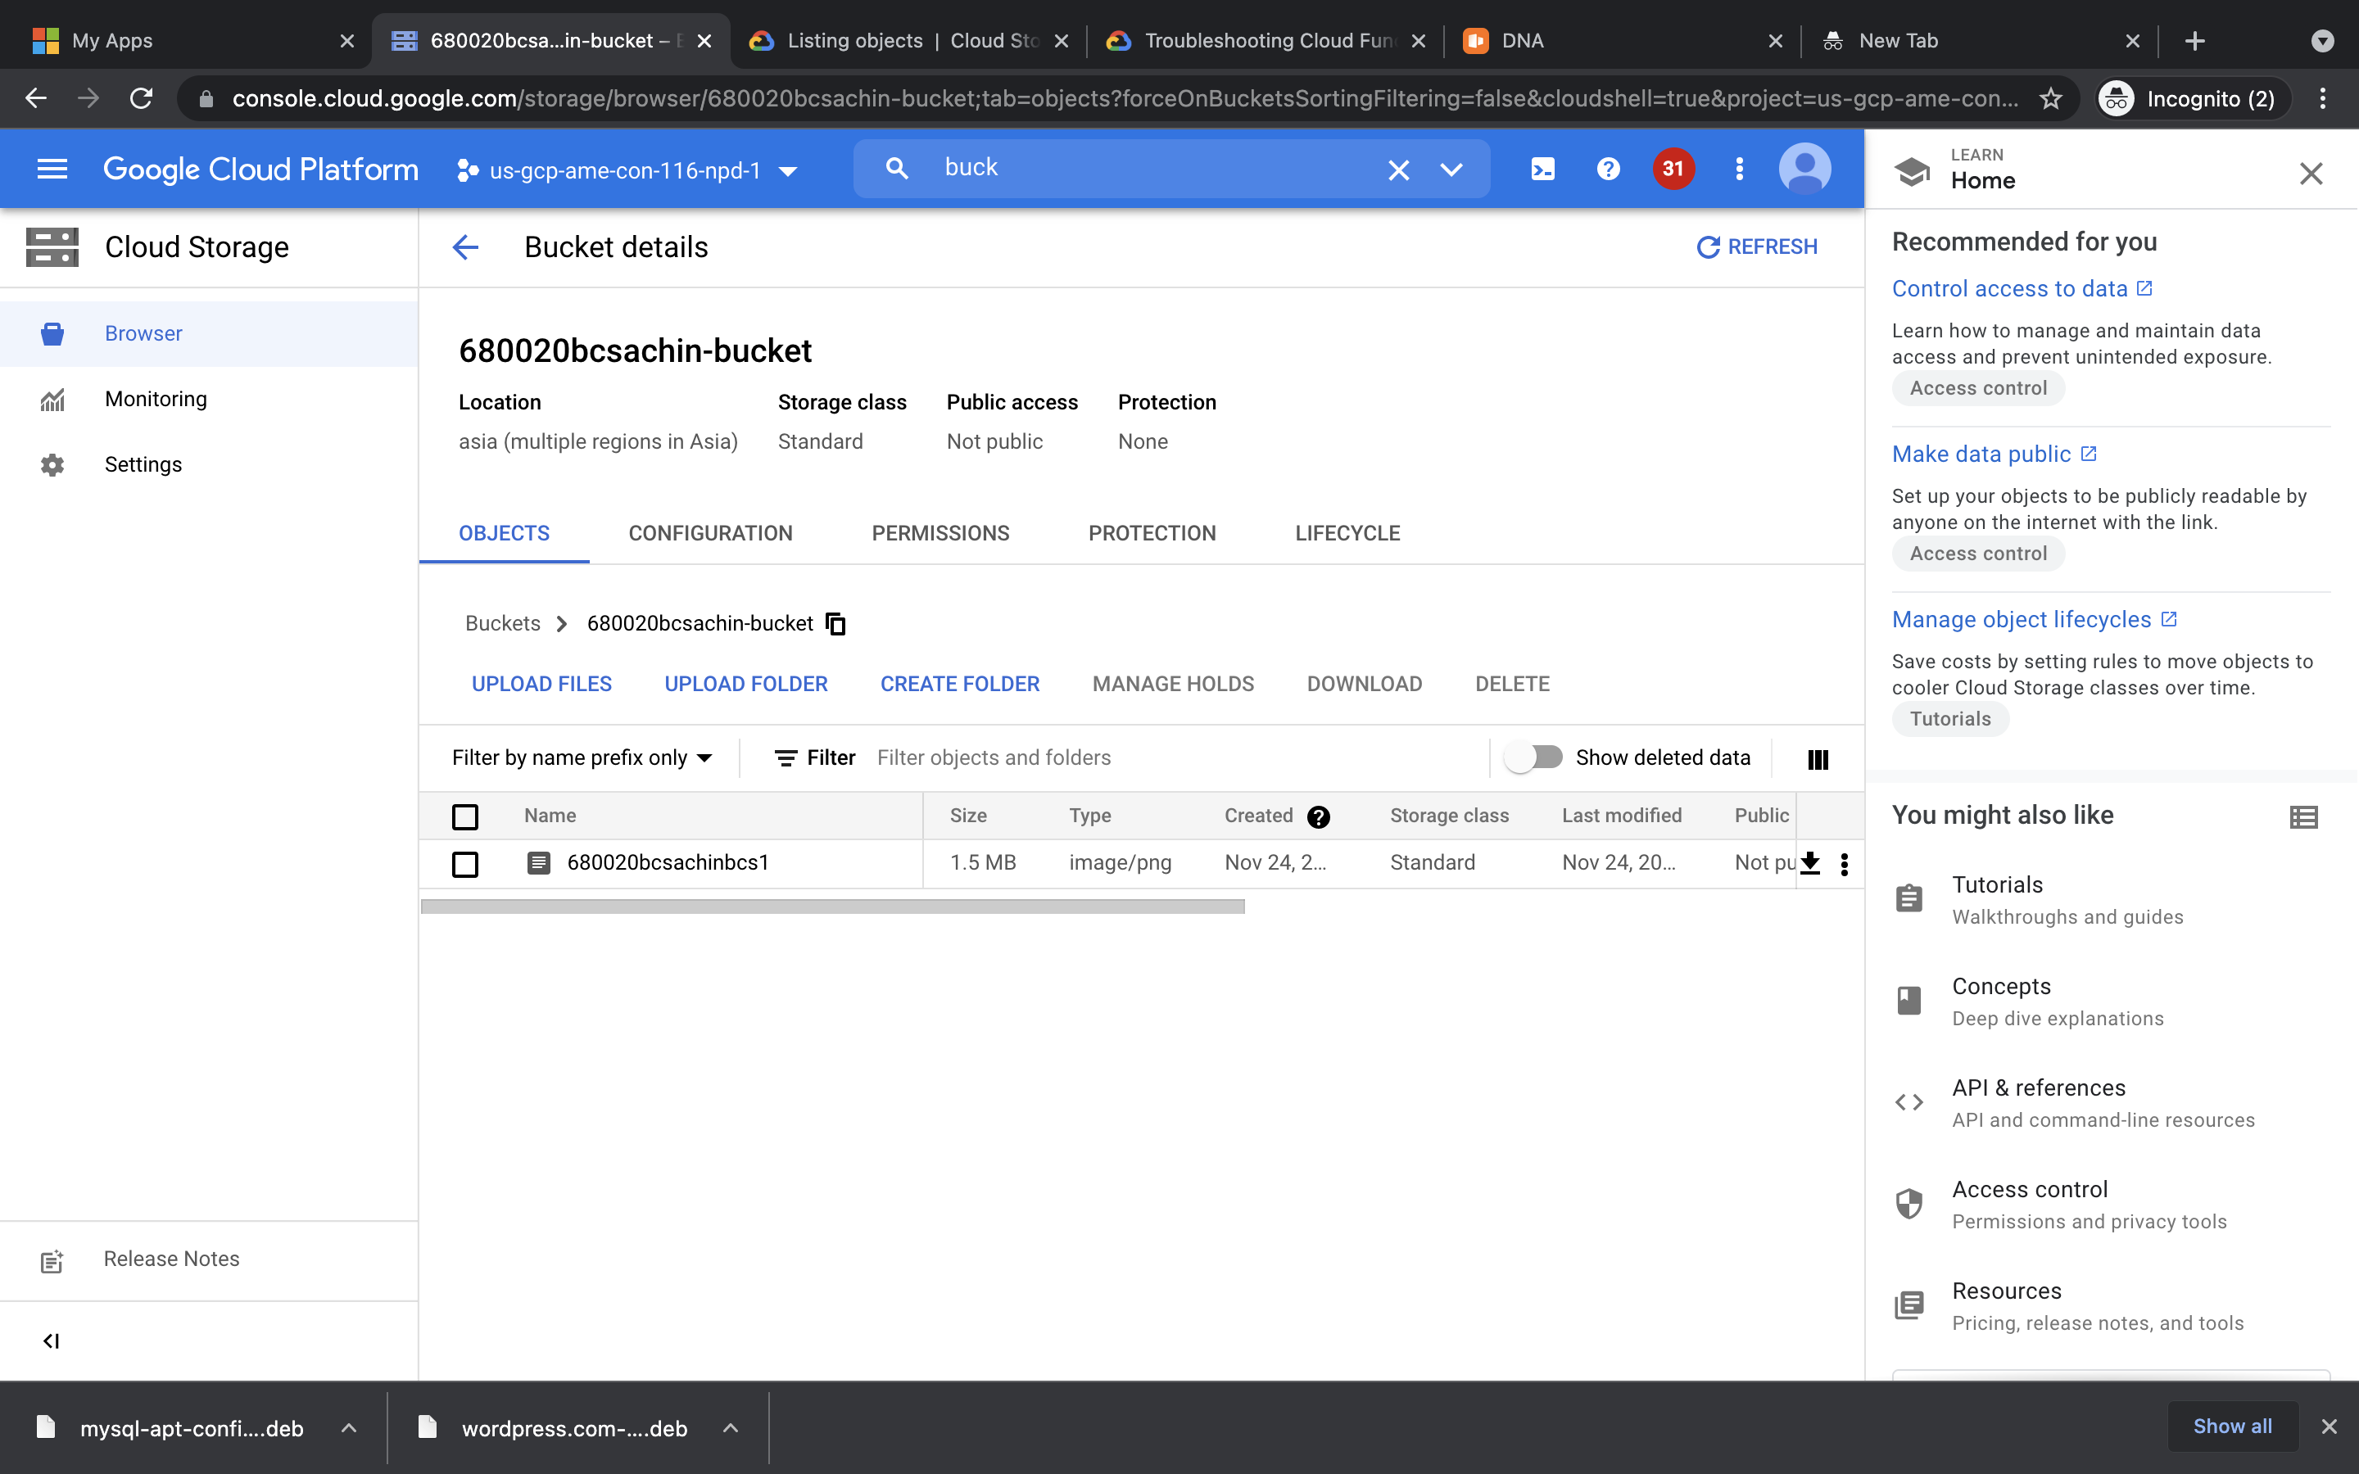

Retrieve the files using below script

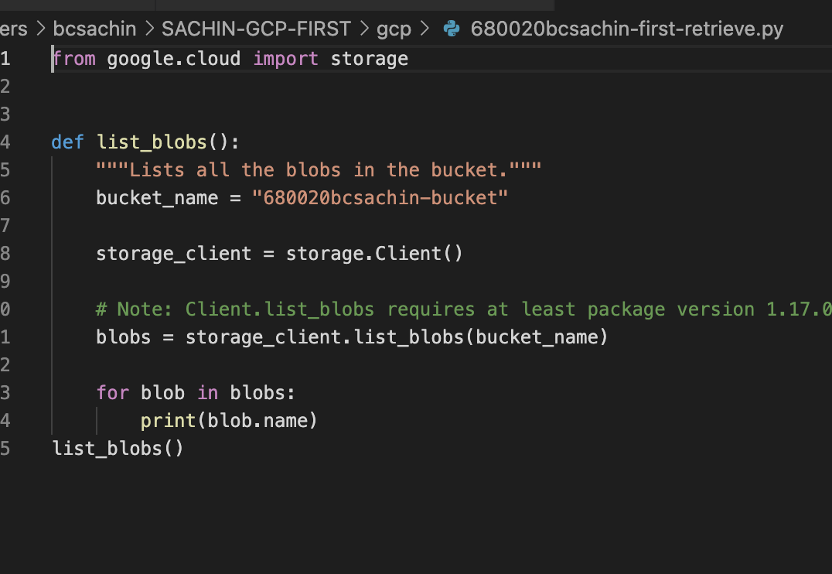

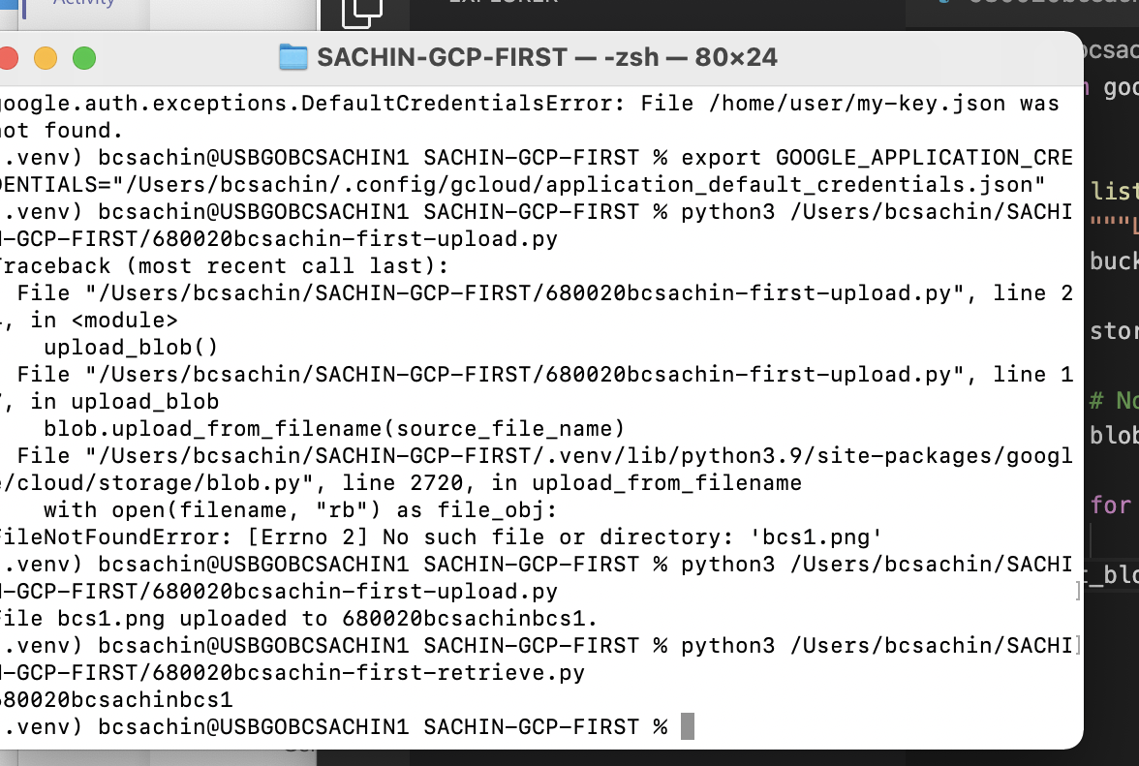

To get total size. Just sum up the size of blobs

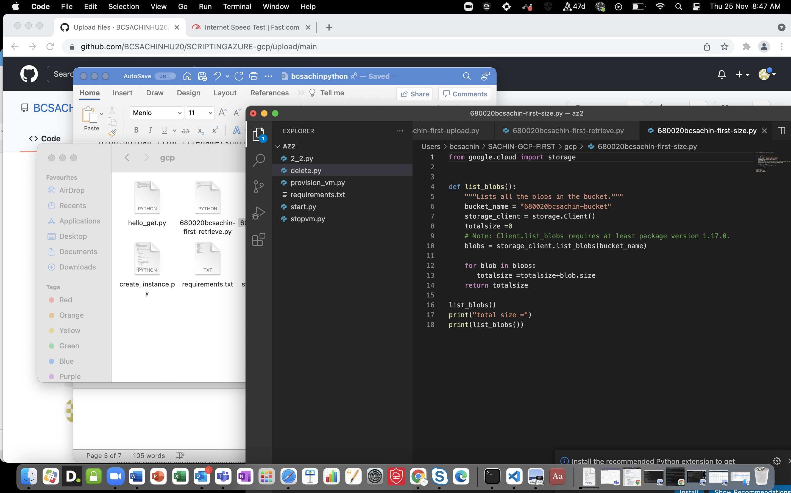

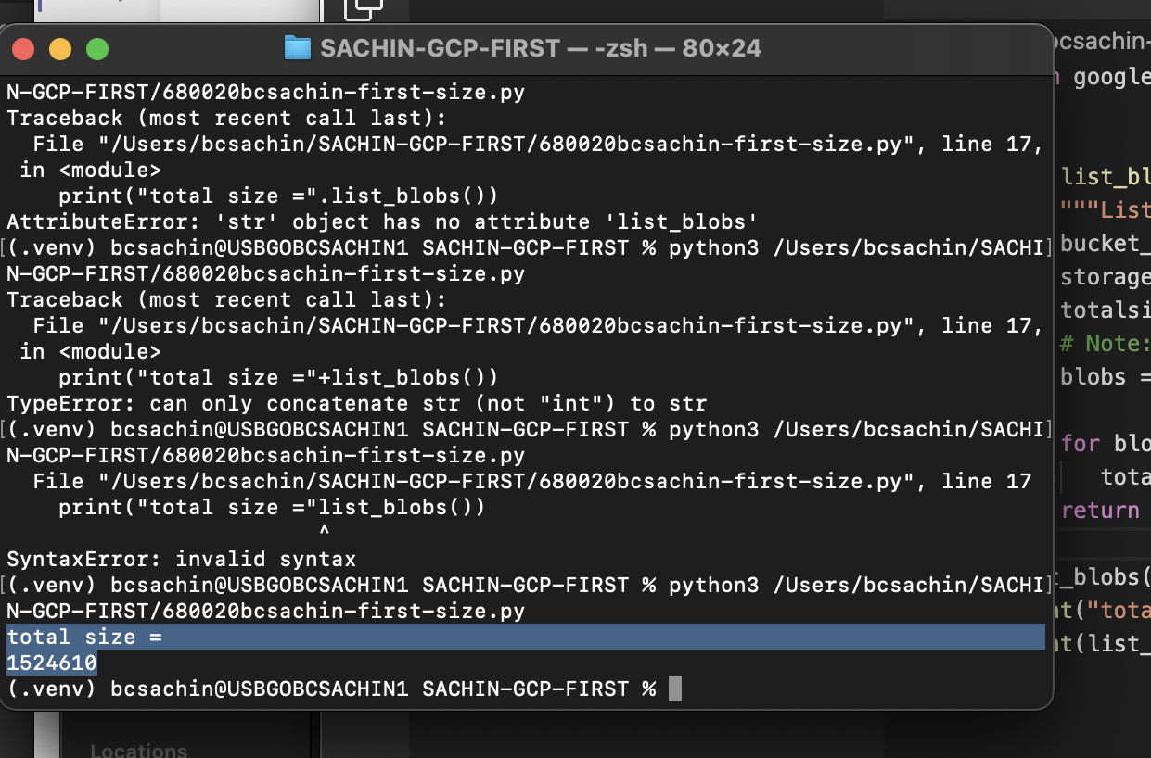

2. create instace using create_instance.py

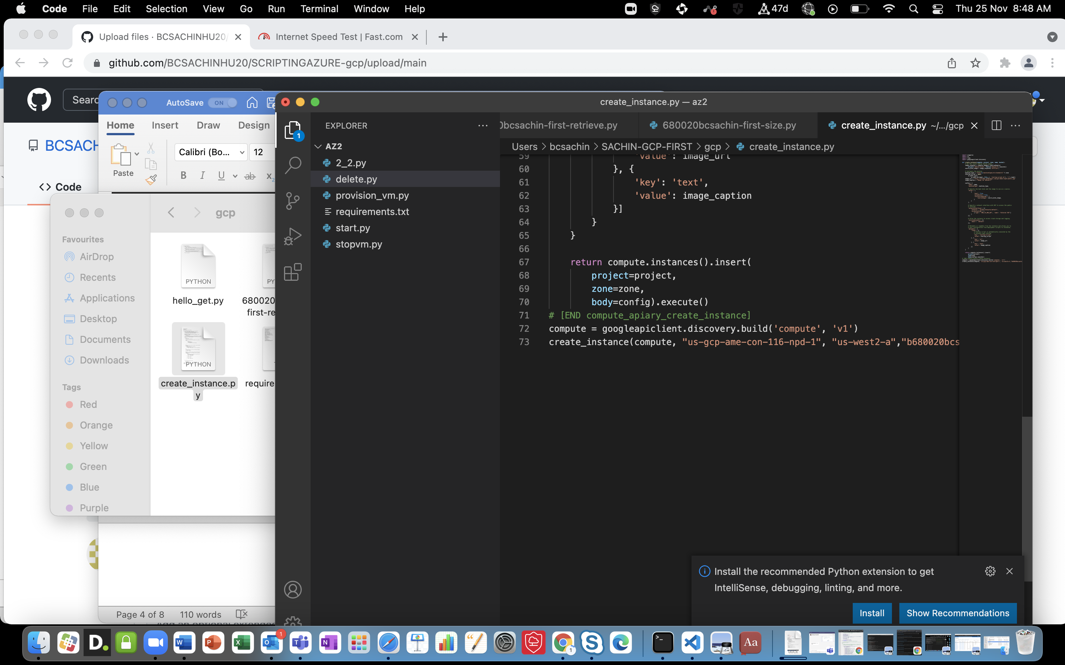

Error in network interface.

3.Write a python script to start/stop Instances based on Tags.

Could not start instance due to some unknown error

4. couldn’t try

5/.

gcloud compute networks subnets list

gcloud compute networks list

gcloud compute instances list

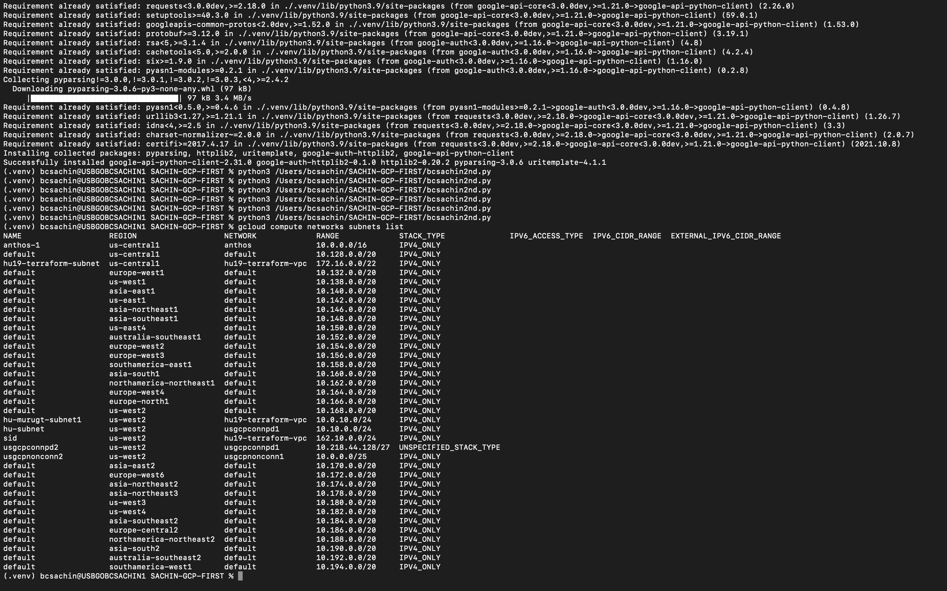

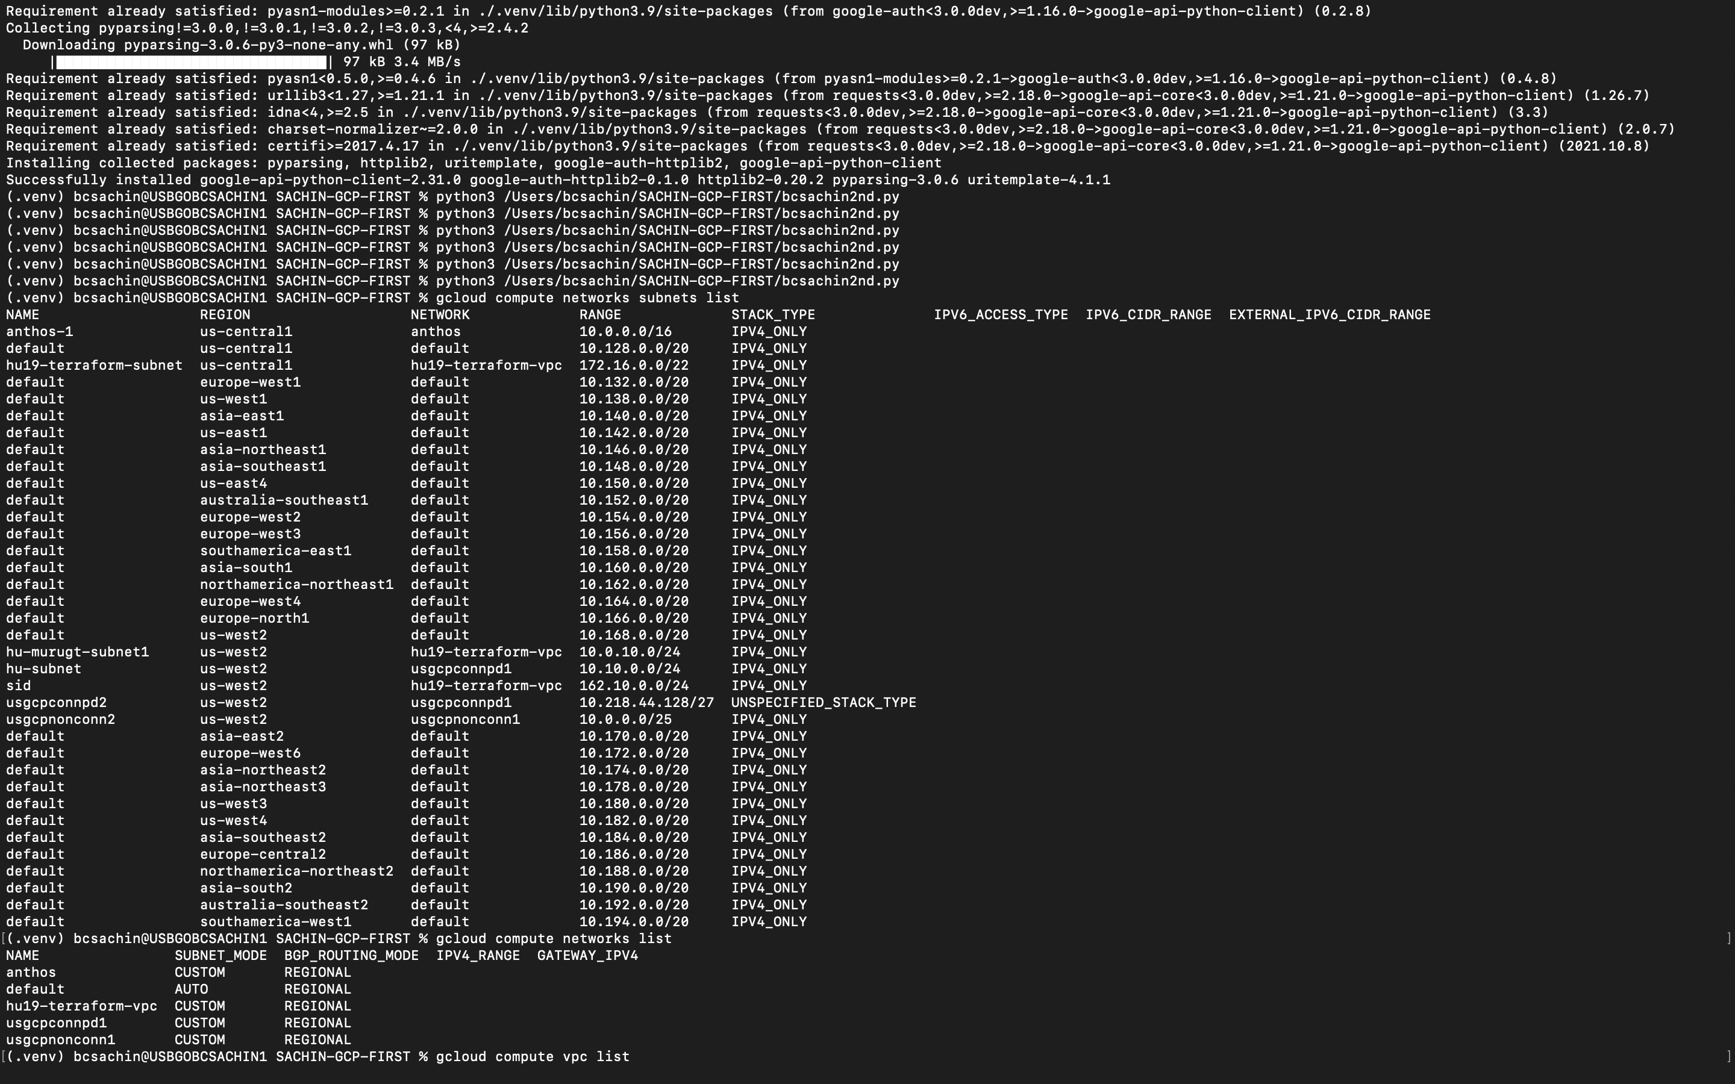

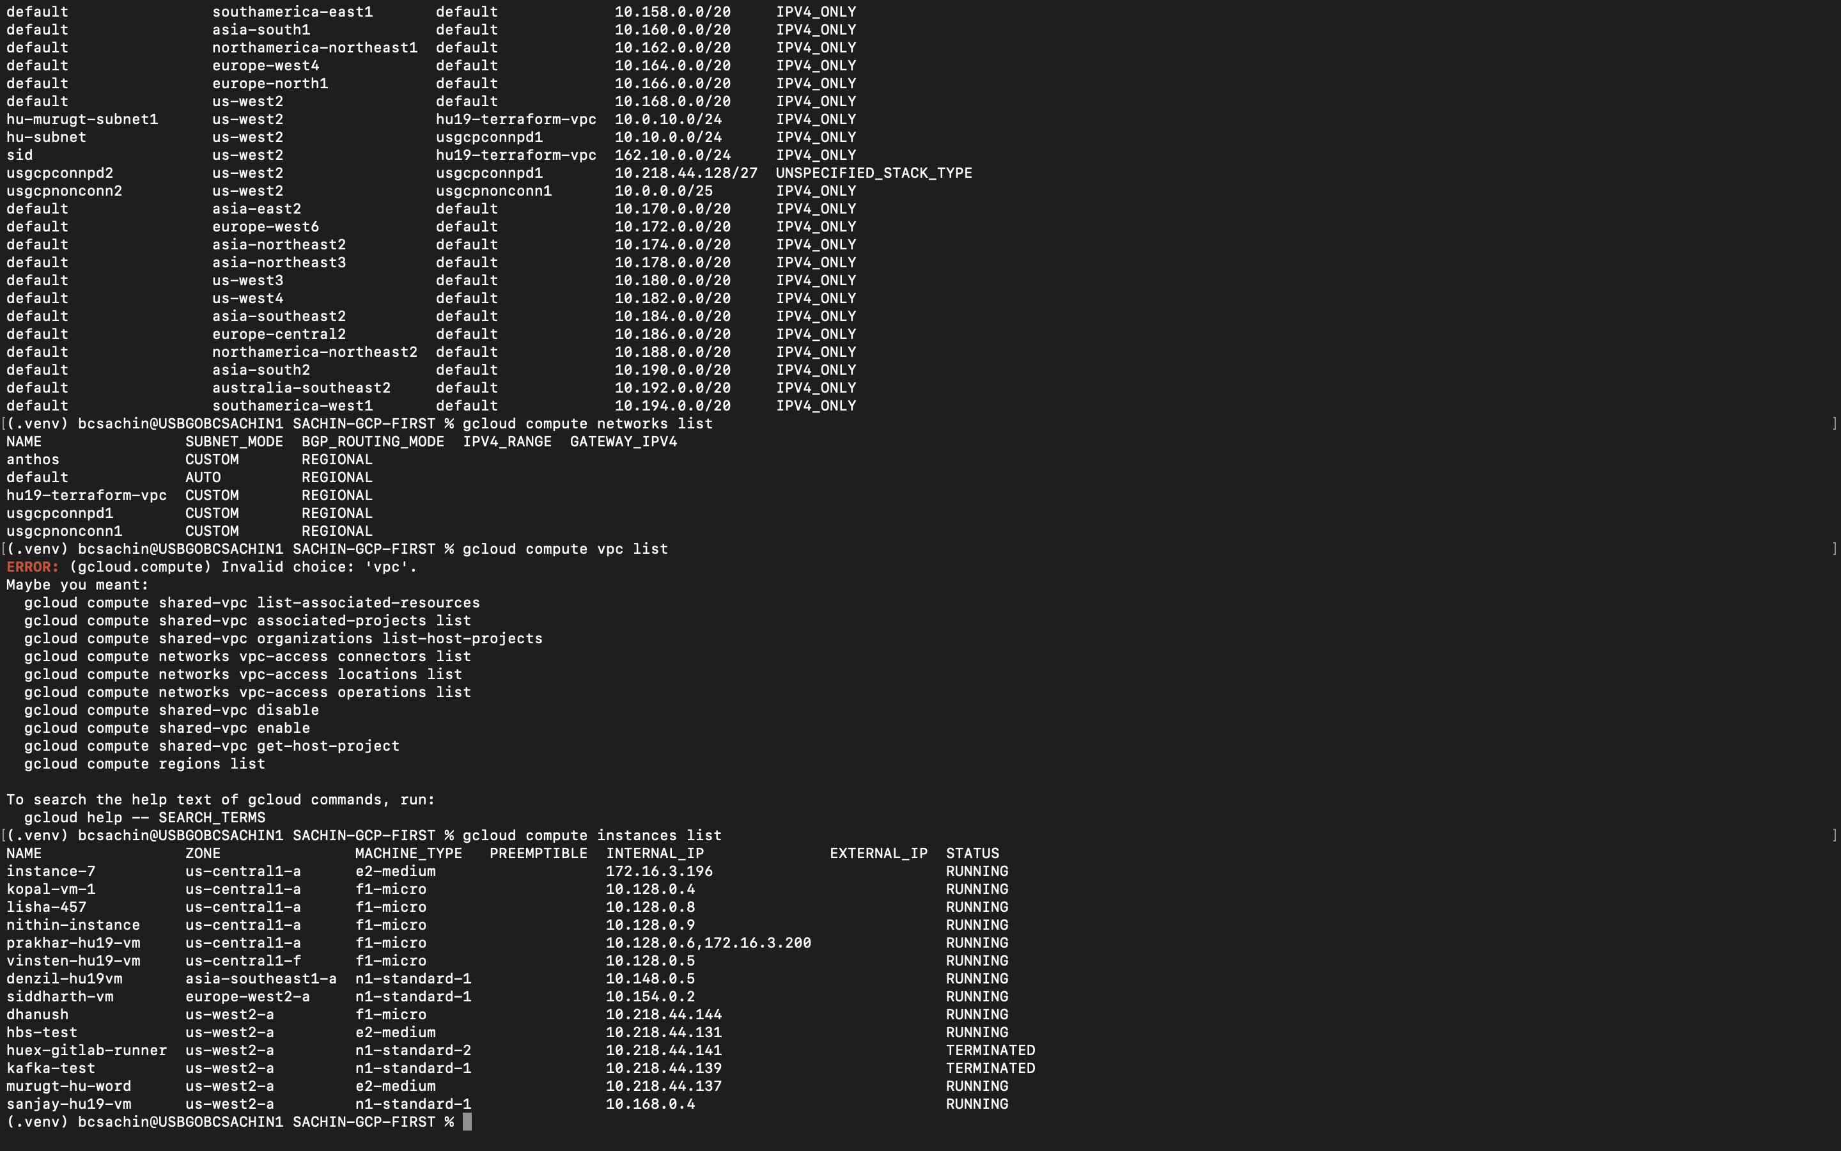

6.

gcloud functions deploy hello_get \

--runtime python39 --trigger-http --allow-unauthenticated

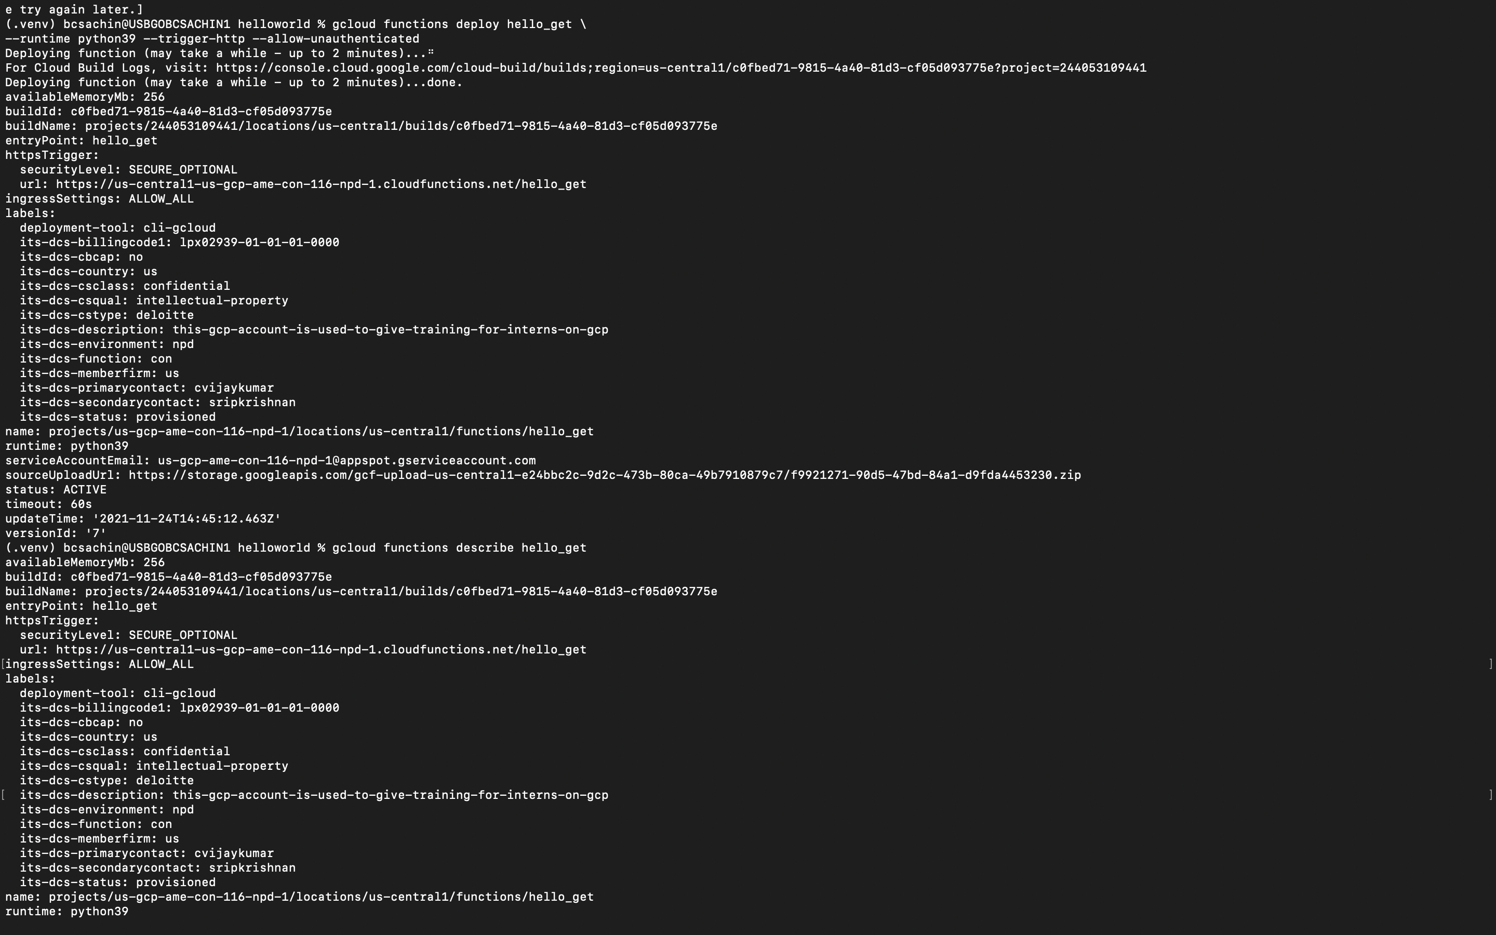

curl https://us-central1-us-gcp-ame-con-116-npd-1.cloudfunctions.net/hello_get

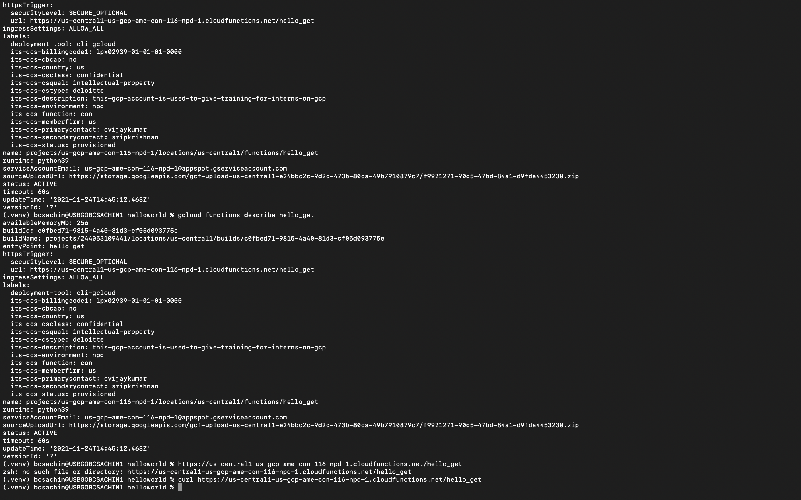

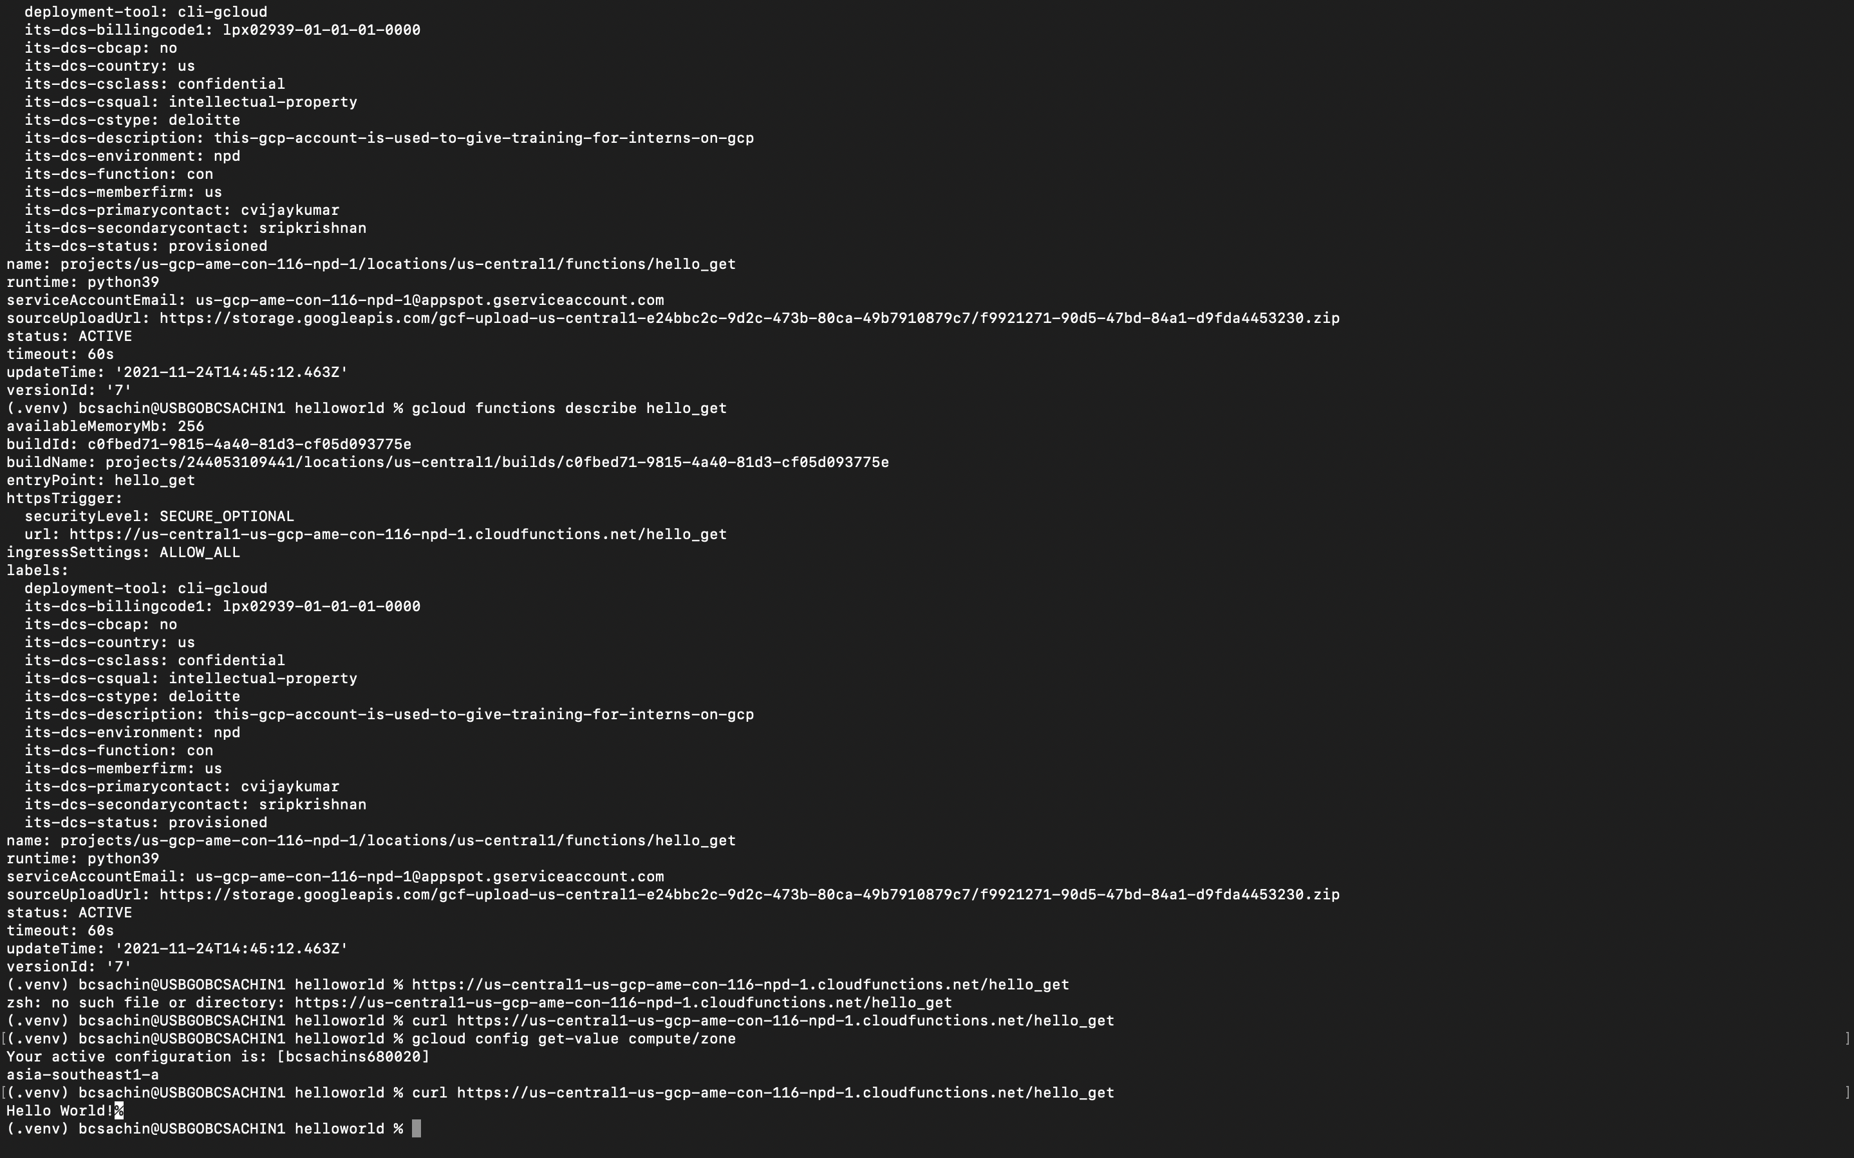

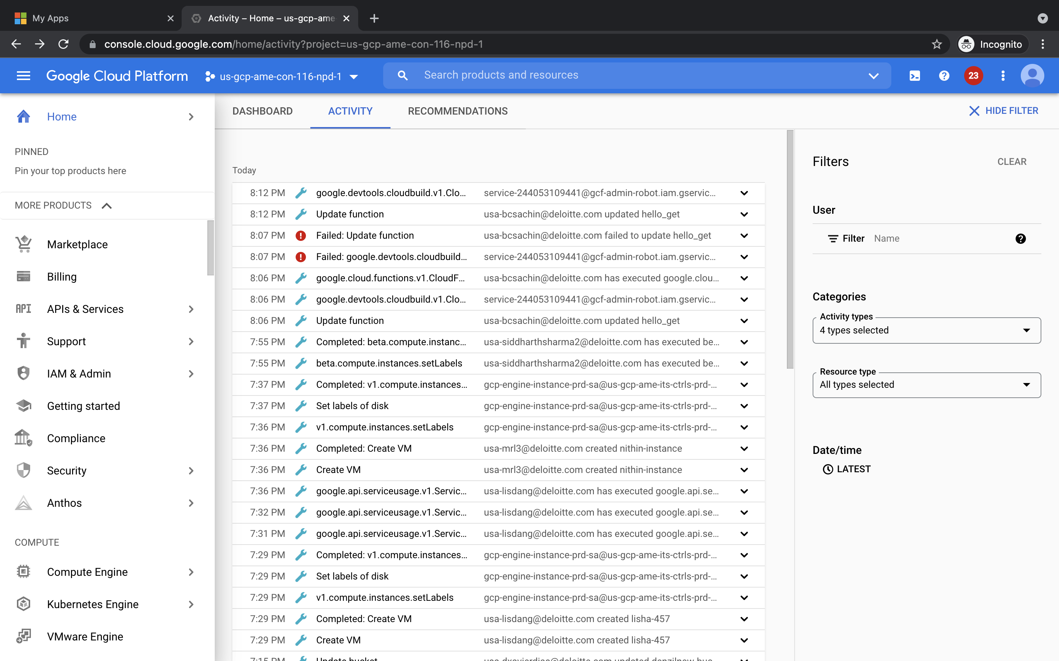

//end